沿江高铁武汉天河站站城一体化区域城市设计
及站区综合体建筑概念方案国际征集公告
ANNOUNCEMENT ON INTERNATIONAL SOLICITATION OF URBAN DESIGN OF WUHAN TIANHE STATION-CITY INTEGRATED AREA AND CONCEPTUAL SCHEMES FOR STATION COMPLEX BUILDING OF YANGTZE HSR

武汉天河站是武汉铁路客运枢纽“五主两辅”的主枢纽之一，是武汉天河空铁枢纽的重要组成部分。武汉天河站的规划建设对于武汉建设交通强国示范城市、全面提升对外辐射能力和影响力具有重大意义，是支撑武汉市建设国家中心城市、长江经济带核心城市和国际化大都市的重点项目。
Wuhan Tianhe Station is one of the master hubs among Wuhan Railway Passenger Hub Stations featuring "five-master two-auxiliary", and also an important part of Wuhan Tianhe Air-Rail Hub. The planning and construction of Wuhan Tianhe Station is of great significance to build Wuhan into a model city with strong transportation system and improve its external radiation ability and influence in an all-round manner. Therefore, it is a key project to support Wuhan in building itself into a national central city, a core city along the Yangtze River Economic Belt and an international metropolis.
本次国际征集目的是坚持世界眼光、国际标准、中国特色、高点定位，借鉴国内外最先进的空铁枢纽片区发展、规划、建设和运营管理经验，征集具有世界领先水平、荆楚地域特色和可实施性强的武汉天河站站城一体化区域城市设计和站区综合体建筑概念方案，指导下一阶段武汉天河站及周边区域规划建设工作。
This solicitation is designed to adhere to global visions, international standards, Chinese characteristics and future-oriented goals, learn from domestically and internationally most advanced experience in development, planning, construction and operation of the air-rail hub area, and solicit the urban design of Wuhan Tianhe station-city integrated area and conceptual schemes for station complex building which are internationally advanced, characteristic of Hubei Region and highly feasible, so as to guide the next phase of planning and construction of Wuhan Tianhe Station and surrounding areas.
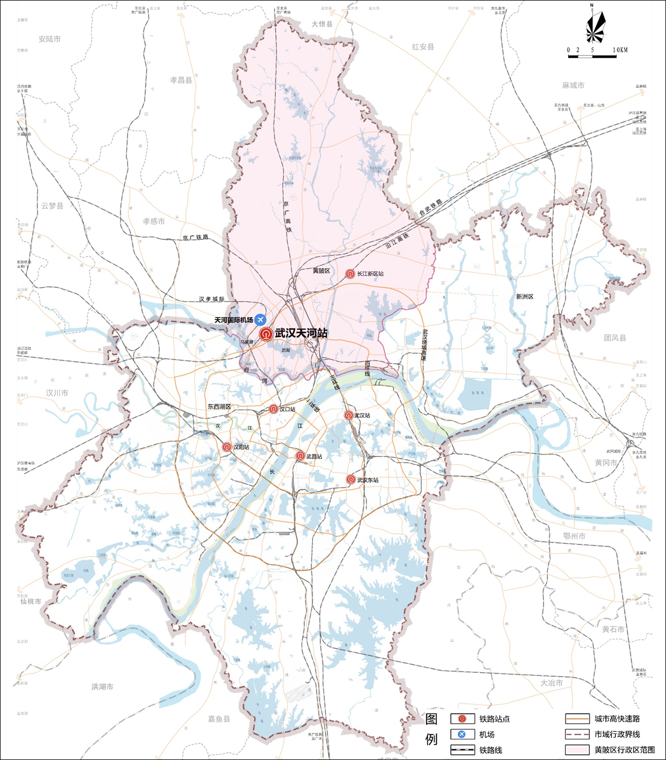
武汉天河站区位图
Wuhan Tianhe Station Location Map

项目名称
I. Project name
沿江高铁武汉天河站站城一体化区域城市设计及站区综合体建筑概念方案国际征集
International Solicitation of Urban Design of Wuhan Tianhe Station-City Integrated Area and Conceptual Schemes for Station Complex Building of Yangtze HSR

主办单位
II. Sponsors
主办方：黄陂区人民政府、武汉市自然资源和规划局
Host: Huangpi District People's Government and Wuhan Natural Resources and Planning Bureau
承办方：武汉生态环境投资发展集团有限公司、武汉市城市建设投资开发集团有限公司（武汉城市铁路建设投资开发有限责任公司）
Organizers: Wuhan Eco Investment Group and Wuhan Urban Construction Investment & Development Group Co., Ltd. (Wuhan Urban Railway Construction Investment & Development Co., Ltd.)

方案征集范围
III. Scope of Scheme Solicitation
（一）研究范围
(I) Scope of Study
为武汉天河空铁枢纽功能区范围，东至盘龙大道，南至机场二通道，西至天河国际机场边界，北至临空南路，面积约44平方公里，可结合规划适当扩大研究范围。
The study aims at the function area of Wuhan Tianhe Air-Rail Hub, which reaches the Panlong Avenue in the east, the Airport Second Expressway in the south, the eastern boundary of Wuhan Tianhe International Airport in the west, and Linkong South Road in the north, covering an area of about 44 km². The scope of study can be appropriately enlarged according to the planning.
（二）“站城一体化区域”城市设计范围
(II) Scope of Urban Design of “Station-City Integrated Area”
东至武汉绕城高速及后湖，南至四环线，西至机场高速及天河国际机场边界，北至临空南路，面积约7.4平方公里。
The scope of design extends eastwards to Wuhan Ring Expressway and Houhu, southwards to Fourth Ring Road, westwards to Airport Expressway and the eastern boundary of Wuhan Tianhe International Airport, and northwards to Linkong South Road, covering an area of about 7.4 km².
（三）“站区综合体”建筑概念方案设计范围
(III) Scope of Design of Conceptual Schemes for “Station Complex Building”
高铁站房及相关附属设施、城际及轨道交通站、各类配套交通车场、需与高铁站统一建设的商业开发空间，各类服务于高铁站的地上、地下集散空间及公共设施等，面积约78公顷。
The scope of design includes high-speed railway station building and related auxiliary facilities, intercity and rail transit stations, all kinds of supporting traffic yards, commercial development spaces to be constructed in a unified manner with the HSR station, all kinds of above-ground and underground distribution spaces and public facilities serving the HSR station, etc., covering an area of about 78 hectares.
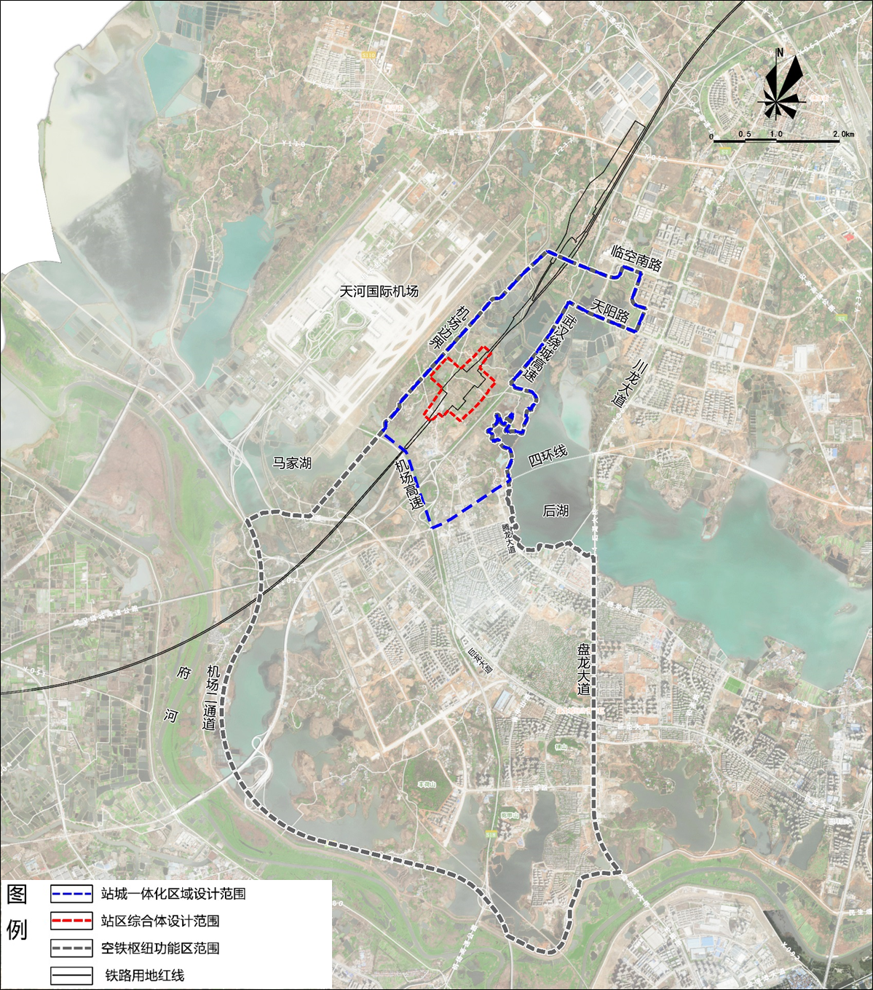
方案征集范围示意图
Scope of Scheme Solicitation

方案征集内容
IV. Contents of Scheme Solicitation
本次活动旨在征集展现中国特色与武汉城市魅力，兼具国际视野与先进理念、富有创意、面向实施的站城一体化区域城市设计和站区综合体建筑概念方案。
The purpose of this event is to solicit the urban design of station-city integrated area and conceptual schemes for station complex building which show the Chinese characteristics and the charm of Wuhan City, reflect both international perspectives and advanced concepts, and are creative and implementation-oriented.
（一）“站城一体化区域”城市设计
(I) Urban Design of “Station-City Integrated Area”
开展站城一体化区域城市设计，达到指导控制性详细规划编制深度。设计应包括（但不限于）功能定位与用地布局、空间形态、景观风貌、交通组织、慢行系统、地下空间、竖向设计、智慧城市、基础设施、分期实施建议、资金平衡及运营等方面内容。
Urban design shall be carried out for the station-city integrated area to provide guidance for the making of regulatory plans. The design shall include (but not limited to) functional orientation and land layout, spatial form, landscape style, traffic organization, non-motorized transport, underground space, vertical design, smart city, infrastructure, suggestions for phased implementation, fund balancing and operations, etc.
站城一体化区域城市设计应注重以下几个方面的工作：一是区域开发与功能业态策划，需论证明确高铁站本体、周边地区及区域层面的主导功能、业态类型、规模结构、空间布局等；二是区域交通系统优化，需处理好轨道交通、内部交通流线组织、车站与周边地区的交通衔接、铁路与机场的无缝衔接等；三是区域空间整体设计，注重高铁站与周边地区的协调，充分发挥区域资源特色，关注站城空间一体化、门户地区建筑及景观的标识性塑造、站前空间与邻近滨水空间整体设计等。
The urban design of station-city integrated area shall focus on the following issues: (i) the regional development and functional form planning, which means demonstrating and defining the dominant function, type of business, scale, structure and spatial layout of the HSR station and its surrounding area and regional level; (ii) the optimization of regional traffic system, which means managing rail transit, internal traffic streamline organization, traffic connection between station and surrounding area, and railway-airport seamless connection, etc.; and (iii) the overall design of regional space, which means paying attention to the coordination between the HSR station and its surroundings, leveraging the characteristics of regional resources with focus on station-city spatial integration, creation of iconic buildings and landscapes in the gateway area, and overall design of space in front of the station and adjacent waterfront space, etc.
（二）站区综合体建筑概念方案设计
(II) Design of Conceptual Schemes for Station Complex Building
站区综合体在方案征集阶段应达到建筑概念方案设计深度,设计应包括（但不限于）设计理念、空间形态设计、建筑风貌设计、功能及业态策划、建筑概念设计、交通设施布局与交通组织、公共空间及景观环境设计、地下空间利用、分期实施建议、投资估算等方面内容。
The design extent of the station complex shall reach the conceptual architectural scheme design extent at the scheme solicitation stage. The design shall include (but not limited to) design philosophy, spatial form design, architectural style design, function and business planning, conceptual design of buildings, transport facilities layout and traffic organization, design of public space and landscape environment, utilization of underground space, suggestions for phased implementation, and investment estimation, etc.
站区综合体建筑概念方案应重点研究以下几个方面关系：一是高铁站房与天河国际机场，二是站房与站前开发区，三是站房与综合开发物业。重点强化站区综合体的标志性，充分体现地域特色，强化综合体内功能、交通、空间、景观等方面的联系，提出设计对策。
The conceptual scheme for station complex building shall give priority to the following relationships: (i) HSR station building and Wuhan Tianhe International Airport; (ii) station building and station development zone; and (iii) station building and comprehensive property development, by highlighting the symbolism of the station complex, fully reflecting the regional characteristics, strengthening internal connectivity in terms of function, transport, space and landscape, and putting forward design strategies thereon.
（三）征集方案成果的整合深化
(III) Integration and Development of the Deliverables of the Scheme Solicitation
以中标方案为核心，整合、吸纳各方案的优点和专家评审意见，形成高水平、可实施的方案，具体包括与天河空铁枢纽功能区城市设计的协调、整合国际征集优胜方案、深化方案设计、形成站区综合体综合开发指引、划分站区综合体工程界面等方面工作内容。
Take the winning scheme as the core, integrate and absorb the advantages of each scheme and expert review opinions, and form a high-level and implementable scheme, specifically including coordination with urban design of Tianhe Air-Rail Hub function area, integration of winning schemes, scheme design development, formation of guidelines for the comprehensive development of station complex, and division of engineering interfaces of the station complex, etc.

报名资格
V. Registration Requirements
应征申请人须为境内、境外合法注册的法人实体或由法人实体组成的联合体，其中联合体内成员不得超过5家，联合体牵头人代表联合体各方成员负责投标和合同实施阶段的主办协调工作，但联合体其他成员在投标签约与履行合同过程中，仍负有连带的和各自的法律责任。已组成联合体的设计机构不得再以自己的名义单独参与，也不得组成新的联合体参与本次征集活动。
The applicant must be a legal entity legally registered at home or abroad or a consortium composed of legal entities. However, the number of members of the consortium shall not exceed 5. The leading member of the consortium is responsible for organizing and coordinating the bidding and contract implementation on behalf of all members of the consortium, while other members of the consortium are still jointly and severally liable for bidding, signing and implementation. Any member already in a consortium shall not participate in this solicitation in its own name or join another consortium.
应征申请人资质要求：在中华人民共和国境内注册的设计机构，须具有相关主管部门核发的城乡规划编制甲级或建筑行业（建筑工程）甲级及以上资质；中华人民共和国境外设计机构，须依本国或本地区管理规定具有执业许可或经营许可，并提供相应的证明材料。
Applicant Qualification Requirements: The domestic design agency as applicant shall have Class A or higher qualifications for urban and rural planning or construction industry (architectural engineering) issued by the relevant competent departments. The foreign design agency as applicant shall, in accordance with the administrative regulations of the country or the region, hold the practicing license or business license and provide relevant evidentiary materials.
应征申请人（独立或联合体）近5年内具有至少以下3项业绩：①具有在建或已建成运营的大型综合交通枢纽建筑工程设计经验和案例；②具有国内外知名建筑的设计经验和案例；③具有丰富的大型枢纽功能区城市规划设计经验和案例。
Applicants (independently or in consortiums) shall have at least 3 of the following achievements in the recent five years: ① experience and cases in the architectural engineering design of large-scale integrated transport hubs that are under construction or have been completed and put into operation; ② experience and cases in the design of renowned buildings at home and aboard; ③ rich experience and cases in urban planning and design of large hub function areas.

报名时间
VI. Registration Deadline
自发布之日起至2022年5月20日17点整（北京时间）截止，所有报名申请文件（包括报名信息登记表、报名申请函）和资格预审申请文件（包括商务资信文件、概念提案，具体详见征集文件）需在截止时间前按要求提交，逾期提交或提交的文件不符合要求的申请概不受理。
The registration shall begin from the date of release and end at 17:00 on May 20, 2022 (Beijing Time). All application documents (including information registration form and application letter) and pre-qualification application documents (including business credit documents and conceptual proposal，see solicitation document for details) shall be submitted as required before the deadline. No late or unqualified applications will be accepted.

报名方式及程序安排
VII. Registration Method and Scheduling
本次方案征集活动分为三个阶段，时间为2022年4月至2022年9月。主办方保留调整日程安排的权利，可根据地方新冠疫情防控等不可抗力因素相应调整征集活动安排。
The scheme solicitation is divided into three stages, lasting from April to September 2022. The Host reserves the right to adjust the schedule, which is subject to force majeure such as local prevention and control of COVID-19.
（一）第一阶段为报名及资格预审阶段，共计4周。设计机构报名后，递交资格预审申请文件，主办方从报名机构中通过资格审查评选6家参与方案编制，电话与网络通知资格审查结果。
(I) Stage 1: registration and prequalification, lasting 4 weeks in total. After registration, design agencies shall submit prequalification application documents, and the Host shall select 6 shortlisted applicants therefrom to participate in scheme preparation, and make an announcement thereon by telephone and on the Internet.
4月下旬，主办方发布征集公告，接受设计机构公开报名。有意参加本次征集活动的应征人需提交盖章的报名信息登记表（附件1）和报名申请函（附件2）（联合体报名的，各成员机构均需提交登记表和申请函）。报名方式：①现场报名：报名信息登记表及申请函可现场提交至湖北省成套招标股份有限公司（武汉市武昌区东湖西路特2号平安财富中心B座八楼）；②邮件报名：报名信息登记表及申请函电子文件以邮件方式提交至邮箱598785214@qq.com。报名机构报名成功后，将收到《沿江高铁武汉天河站站城一体化区域城市设计及站区综合体建筑概念方案国际征集》的征集文件。未通过以上方式报名获取征集文件的，后续递交的资格预审申请文件将可能被拒绝。
In late April, the Host shall announce this solicitation, which is open to the design agencies. Those which are interested in this solicitation shall submit a sealed information registration form (Annex 1) and an application letter (Annex 2) (for those which apply in the name of a consortium, the registration form and application letter are required for all members of the consortium). Registration method: ① in case of on-site registration: the information registration form and application letter may be submitted on site to Hubei Provincial Complete Tendering Corporation Ltd. (Address: Floor 8, Block B, Ping An Fortune Center, No. T2 Donghu West Road, Wuchang District, Wuhan); ② in case of registration by e-mail: the electronic information registration form and application letter shall be addressed to 598785214@qq.com. Successful applicants will receive the solicitation document titled International Solicitation of Urban Design of Wuhan Tianhe Station-City Integrated Area and Conceptual Schemes for Station Complex Building of Yangtze HSR. If applicants fail to register for the solicitation document as described above, their subsequent submittals may be rejected.
设计机构（联合体）根据征集文件资格预审要求，编制完成资格预审申请文件，于截止时间2022年5月20日17点整（北京时间）之前,现场提交资格预审申请文件到湖北省成套招标股份有限公司（武汉市武昌区东湖西路特2号平安财富中心B座十楼），迟到的文件将不予接收。
The design agencies (consortiums) will, according to the pre-qualification requirements for solicitation, prepare pre-qualification application documents which shall be submitted on site to Hubei Provincial Complete Tendering Corporation Ltd. (Address: Floor 10, Block B, Ping An Fortune Center, No. T2 Donghu West Road, Wuchang District, Wuhan) prior to the deadline, i.e. 17:00, May 20, 2022 (Beijing Time). No late documents will be accepted.
5月下旬，主办方组织资格预审评审会，评选6家入围设计机构（联合体），电话与网络同步公告。
In late May, the Host shall organize a pre-qualification review meeting, at which six shortlisted design agencies (consortiums) will be selected and announced simultaneously via telephone and Internet.
主办方向入围设计机构提供征集文件补充文件（含详细的设计任务书和基础资料）。入围机构递交盖章《应征确认函》原件，并缴纳应征保证金。
The Host shall provide supplemental solicitation documents (including detailed design specification and basic data) to the shortlisted applicants. The shortlisted applicants shall submit the original sealed Application Confirmation and pay security deposit.
（二）第二阶段为方案征集及评审阶段，共计12周。设计机构完成征集方案正式成果，主办方组织专家评审会，对6家设计机构提交的征集方案正式成果进行评审，评选出前三名为优胜方案并作为推荐候选人。经主办方组织专题会议研讨后上报武汉市人民政府，确定中标机构并予以公示。
(II) Stage 2: scheme solicitation and review, lasting 12 weeks in total. Design agencies shall complete deliverables. The Host shall organize an expert review meeting to review the deliverables submitted by six design agencies, and select the top three winning schemes as recommended candidates, which shall be reported to Wuhan Municipal People's Government after ad hoc meeting discussion. The winner shall be determined and made public.
（三）第三阶段为征集方案整合及深化阶段。以优胜方案为核心，由中标机构整合形成高水平、可实施的设计方案，并对空铁枢纽功能区城市设计提出优化建议。
(III) Stage 3: scheme integration and development. The winner shall take the winning schemes as the core and integrate them into a high-level practical design scheme, and put forward suggestions for optimizing the urban design of the air-rail hub function area.

方案征集费用
VIII. Scheme Compensation
本次方案征集费用均以人民币支付，税费均由设计机构（联合体）自理。经过专家评审后，符合设计要求的设计机构（联合体），依据其排名将获得如下方案征集费用：
The scheme compensation in this solicitation will be paid in RMB, and any taxes and fees incurred therefrom shall be borne by design agencies (consortiums). Design agencies (consortiums) that meet the design requirements upon review by experts will receive the following compensation depending on their rankings:
中标机构：方案征集费700万元（含方案征集费300万元及整合深化方案费用400万元）。
Winner: Compensation of RMB 7 million (including the compensation of RMB 3 million for scheme solicitation and the compensation of RMB 4 million for scheme integration and development).
第二、三名设计机构：方案征集费各300万元。
Second and third places: Compensation of RMB 3 million separately.
第四、五、六名设计机构：方案征集费分别为250万元、200万元、150万元。
Fourth, fifth and sixth places: Compensation of RMB 2.5 million, RMB 2 million and RMB 1.5 million respectively.
设计机构以设计联合体名义参加征集活动的，承办方将只与联合体的牵头方联系和结算。境外设计机构若无法使用该机构账户收取人民币的，可授权境内合法独立法人代收款项。
If design agencies participate in the solicitation in the name of consortiums, the organizer will only contact and settle with the leading member thereof. If a foreign design agency cannot use its account to collect RMB funds, it may authorize a domestic independent legal entity for collection.
如承办方或评审专家组认为设计机构（联合体）提交的应征设计文件未达到约定的设计工作深度及成果要求的，承办方可相应支付部分或不支付其方案征集费用。
If the organizer or review panel holds that the deliverables submitted by any design agency (consortium) fail to reach the agreed design extent and deliverables requirements, the organizer may correspondingly pay a part of or not pay the compensation thereto.
设计机构（联合体）参加本次方案征集活动的所有费用（含差旅费、住宿费等）均自行承担。
Design agencies (consortiums) shall bear all expenses for participating in this solicitation (including travel and accommodation expenses).

咨询及联系
IX. Consulting and Contact
（一）协办单位
(I) Co-organizer
武汉市规划研究院
Wuhan Planning & Design Institute
联系人：程梦 13886024123；何迎佳 18086526180
Contact: Cheng Meng 13886024123; He Yingjia 18086526180
（二）招标咨询机构
(II) Tender Consultancy Services Agency
湖北省成套招标股份有限公司
Hubei Provincial Complete Tendering Corporation Ltd.
联系人：吴广浩 13871104423
Contact: Wu Guanghao 13871104423
电子邮箱: 598785214@qq.com
E-mail: 598785214@qq.com
联系地址：武汉市武昌区东湖西路特2号平安财富中心B座十楼
Address: Floor 10, Block B, Ping An Fortune Center, No. T2 Donghu West Road, Wuchang District, Wuhan
邮政编码：430071
Postal Code: 430071

其他
X. Miscellaneous
1、主办方对本次方案征集的设计方案享有使用权，并可以进行展览、印刷、出版等。
1. The Host has the right to use the design schemes submitted for this solicitation, and may exhibit, print and publish them.
2、所有报送的设计文件均不退回。
2. All design documents submitted will not be returned.
3、征集文件解释权归主办方所有。
3. The Host reserves the right to interpret the solicitation documents.
4、本次报名和征集活动将在公平、公正、公开的原则下进行，如有纠纷，将按中国现行法律、法规，通过友好协商或仲裁程序解决。
4. The registration and solicitation is based on the principles of fairness, impartiality and openness. Any dispute arising therefrom shall be settled through friendly negotiation or arbitration in accordance with China's current laws and regulations.
附件1
Annex 1
沿江高铁武汉天河站站城一体化区域城市设计及站区综合体建筑概念方案国际征集报名信息登记表
Information Registration Form for International Solicitation of Urban Design of Wuhan Tianhe Station-City Integrated Area and Conceptual Schemes for Station Complex Building of Yangtze HSR
设计机构：（盖章或签字）
Design Agency (Seal or Signature):
公司注册名称
Registered Company Name
公司简介
Company Profile
公司详细资料
Company Details
国家或地区
Country or Region
法定代表人
Legal Representative
常驻地址
Permanent Address
电话
Tel.
传真
Fax
网址
Website
电子邮箱
E-mail
公司成立日期
Date of Establishment
设计资格的种类/级别（如有）
Category/Grade of Design Qualification (if any)
本项目联系人
Contact Person for This Project
姓名
Name
职称/职务
Title/Position
电话
Tel.
传真
Fax
电子邮箱
E-mail
其他证明文件
Other Supporting Documents
有效营业执照（或商业登记证明）（提供复印件，加盖公章）
Valid business license (or business registration certificate) (photocopy affixed with official seal)
企业资质证明文件（复印件，加盖公章,如有）
Enterprise qualification certificate (photocopy affixed with official seal, if any)
联合体所有机构名称：（牵头人排第一位）
All members of the consortium: (the leading member is ranked No.1)
注：
Notes:
1、此表填写完成后发送至598785214@qq.com电子邮箱，随本表请附应征人的营业执照和资质证书/资格证明文件扫描件（如有）。
1. After completion, this form is sent to 598785214@qq.com. Please attach the scanned copies of the applicant's business license and qualification certificates/credentials (if any).
2、邮件标题应注明应征人名称和“沿江高铁武汉天河站站城一体化区域城市设计及站区综合体建筑概念方案国际征集”。
2. The applicant name and the words "International Solicitation of Urban Design of Wuhan Tianhe Station-City Integrated Area and Conceptual Schemes for Station Complex Building of Yangtze HSR" shall be indicated in the "subject" line of the e-mail.
3、此表须发送可编辑格式文档和盖章或签字的PDF扫描版。
3. Please send a scanned PDF form which is editable and sealed or signed.
附件2
Annex 2
沿江高铁武汉天河站站城一体化区域城市设计及站区综合体
建筑概念方案国际征集公告报名申请函
Application Letter for International Solicitation of Urban Design of Wuhan Tianhe Station-City Integrated Area and Conceptual Schemes for Station Complex Building of Yangtze HSR

致：武汉生态环境投资发展集团有限公司
To Wuhan Eco Investment Group,

关于贵单位发布的“沿江高铁武汉天河站站城一体化区域城市设计及站区综合体建筑概念方案国际征集公告”中的各项条款、要求和相关内容，我司均已详细认真审阅过，各项条款、要求及相关内容均清楚明确。我司自愿申请参加本项目的方案征集活动，并作出以下承诺：
We have thoroughly and carefully reviewed the terms, requirements and relevant contents in the documents related to the Announcement on International Solicitation of Urban Design of Wuhan Tianhe Station-City Integrated Area and Conceptual Schemes for Station Complex Building of Yangtze HSR, and the terms, requirements and relevant contents are clear and confirmed to be correct. We voluntarily apply for the solicitation and undertake as followings:
（1）我司完全同意“沿江高铁武汉天河站站城一体化区域城市设计及站区综合体建筑概念方案国际征集”的全部安排并遵照执行。
(1) We fully agree to all arrangements for the International Solicitation of Urban Design of Wuhan Tianhe Station-City Integrated Area and Conceptual Schemes for Station Complex Building of Yangtze HSR and will comply with them.
（2）我司保证所提交资料真实、合法和有效，并承担相关的法律责任。
(2) We guarantee that any information submitted is true, legal and effective and that we will bear the relevant legal liabilities.
（3）我司保证全部满足贵单位公告中申请人资格要求，可以参加本项目的资格预审。
(3) We guarantee that we will meet all applicant qualification requirements in your announcement and that we can participate in the prequalification for the project.
（4）我司接受贵单位公告中信息发布的方式，并自行承担因我司自身原因造成的文件缺失等对本次审查结果产生的任何影响。
(4) We accept the way in which the information is published in your announcement and will bear any impact of the lack of documents caused by our own reasons on the results of the prequalification.
（5）如有违反上述要求的，我司承诺愿无条件承担因此对贵单位造成的任何损失和不利影响的责任。
(5) In case of any violation of the above requirements, we undertake that we will unconditionally bear the liability for any loss and adverse effect on you.

设计机构：（盖章或签字）
Design Agency (Seal or Signature):
法人代表或授权代表签字：
Signature of Legal Representative or Authorized Representative:
时间：**年**月**日
Date:

